AI-powered software for radiation oncology clinics

Data driven solutions for treatment planning in radiation therapy.

Mohammed Amine Boussetta

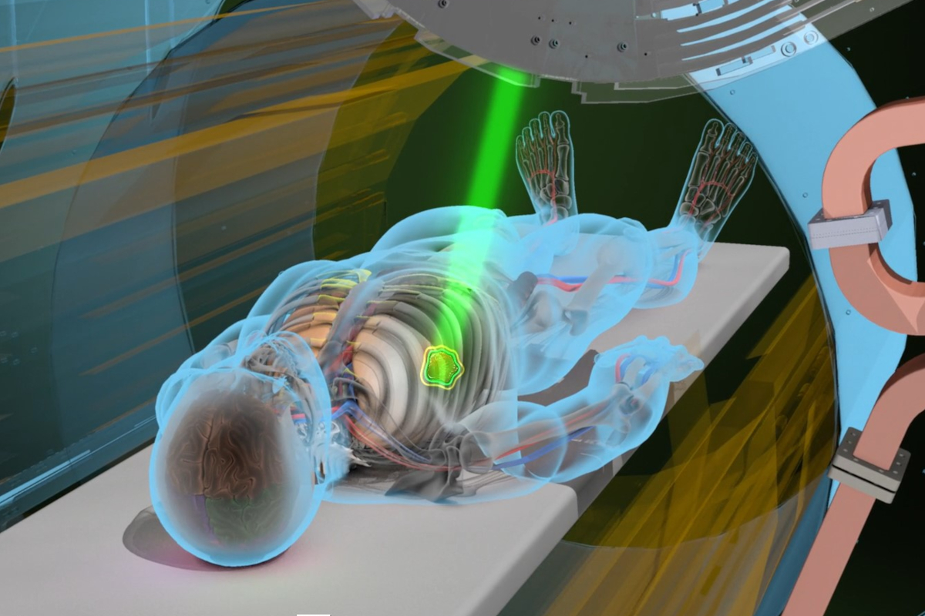

# Introduction

On a global scale, in the year 2020, a total of 18,094,716 million cases of cancer were diagnosed. Within Morocco, the reported caseload amounted to 58,963 cases, characterized by an age-standardized incidence rate of 147.3 per 100,000 individuals and an age-standardized mortality rate of 87.4 per 100,000 individuals. These epidemiological data establish cancer as a prominent contributor to mortality within the country. A diverse array of methodologies is available for the treatment of cancer, encompassing but not restricted to chemotherapy, hormone therapy, hyperthermia, immunotherapy, and radiation therapy. The selection of an appropriate treatment regimen hinges upon the specific cancer type and its stage of advancement. Notably, many patients receive a combination of therapeutic modalities, such as a surgical intervention coupled with chemotherapy and radiation therapy.

Radiation is employed at low doses in diagnostic X-rays to visualize the internal body structures, such as teeth or fractured bones. Intriguingly, at higher doses, radiation is used to either kill cancer cells or impede their growth by causing damage to their DNA. When cancer cells' DNA is irreparably damaged, they cease dividing or undergo cell death. These damaged cells are subsequently broken down and eliminated by the body, summarizing the fundamental concept of radiotherapy. Two notable methods exist for radiation therapy. Internal radiation therapy involves the insertion of a radiation source inside the body, while external beam radiation therapy utilizes a machine to direct radiation precisely at the cancerous site. The latter is a localized treatment, focusing on a specific region of the body. Its primary objective is to administer a concentrated radiation dose to the tumor while minimizing exposure to surrounding healthy tissue.

Among various external beam radiation techniques, there has been a notable shift towards Intensity-Modulated Radiation Therapy (IMRT). IMRT represents an advanced form of high-precision radiotherapy that employs computer-controlled linear accelerators to deliver accurate radiation doses to malignant tumors or specific regions within the tumor. IMRT achieves enhanced precision by adjusting the intensity of the radiation beam across numerous small spatial volumes. Treatment planning involves the use of 3-D computed tomography (CT) or magnetic resonance imaging (MRI) scans of the patient, coupled with dose calculations, to determine the optimal intensity pattern for radiation dosage that best matches the tumor's three-dimensional (3-D) structure. Typically, combinations of multiple intensity-modulated fields originating from various beam directions create a customized radiation dose distribution that maximizes tumor irradiation while minimizing exposure to adjacent healthy tissues.

# Main problem

As of the present, the efficacy of dosimetric planning within most treatment planning systems remains predominantly contingent upon human operators. Parameters such as the configuration of radiation beams, the generation of optimization-assist volumes, the establishment of targeted dose objectives, the imposition of optimization constraints, and the allocation of weighted priorities to attain the desired equilibrium between the Planning Target Volume (PTV) and various Organs at Risk (OARs) represent variables of substantial consequence, profoundly influencing the final therapeutic outcome and, consequently, the clinical benefit to patients. It is noteworthy that, despite the adequacy of dose constraints advocated by international guidelines, they do not ensure the attainment of the optimal dosimetric proposal. This, in turn, suggests the potential for further refinement and enhancement in the optimization process.

**Data-driven solutions:** To enhance the efficiency of treatment planning, research has delved into data-driven approaches that leverage knowledge derived from previous cases to forecast outcomes for new cases. An illustrative instance of this concept emerged over a decade ago in the form of knowledge-based planning (KBP), particularly in the context of radiotherapy treatment planning. KBP methods can be broadly categorized into two main classes: I) Conventional KBP Methods and II) Deep Learning (DL)-Based KBP Methods. Conventional KBP encompasses techniques that employ a spectrum of anatomical and geometrical features (such as distances to target structures, volumes of target and OAR structures, etc.) to construct a mathematical or statistical model. Subsequently, this model is employed to predict various dosimetry characteristics, including dose–volume metrics, dose–volume histograms (DVHs), and spatial dose distributions, for a novel case.

In contrast, DL has garnered substantial attention and been extensively investigated for a variety of image-related tasks, including image registration and segmentation, primarily driven by the remarkable capabilities of convolutional neural networks (CNNs). For instance, the U-Net architecture, originally devised for image segmentation, has recently been harnessed to forecast radiation dose distribution without the necessity for the intricate dose computations conventionally employed in treatment planning. Unlike conventional KBP methods, which rely on handcrafted features, DL methods can autonomously extract image features directly from raw data (e.g., CT scans, contours, dose maps, etc.) that are tailored to the specific prediction task. Consequently, a pivotal distinction between traditional and DL-based KBP resides in their respective approaches to incorporating prior knowledge.

# Contribution

We develop a software tool with DICOM standard interoperability, capable of advanced image computing, particularly allowing the estimation of geometric disposition of structures through. Moreover, our software automatically exploits existing RT dose and RT structure files of individual patients to constitute data sets that are fed into our dose prediction module to train different machine learning models and compare their performance on a predefined validation set. Users can save then the validated dose prediction model and use it for new cases. Following are the projects tasks categorized by skill set:

**Applied mathematics.**

* Define the adequate mathematical abstraction to characterize the geometry of structures
* Build fast mathematical procedures to evaluate geometric measurements such as: Hausdorff distance, Fréchet distance, minimum clearance, minimum bounding radius, overlapping volume, etc.
* Evaluate theoretical complexities of state-of-the-art approaches in the context of KBP (i.e., time complexity, memory complexity)

**Data science**

* Data engineering, including data collection, cleansing and preparation
* Feature extraction, selection and eventual augmentation
* Choose adequate ML models for the prediction task using cross-validation
* Report on the performance of the selected model and compare its performance to existing methodology of Institution B.

**Full-stack development**

* Implement a secure database for storing DICOM RT dose and RT Structure files
* Build a framework for DICOM file interrogation (i.e., read and write)
* Implement the algorithms designed by the applied mathematics engineer.
* Integrate the ML model created by the data scientist into the production environment
* Maintain a clear documentation of the software code

**Front-end development**

* Create quality mockups and prototypes
* Develop a web-application to host core functionalities of our software
* Design a user interface in collaboration with the full-stack developer and Institution B users to improve usability
* Optimize applications for maximum speed